**Introduction to Computing**

**Bonus lab**



**Faculty of Information Technology**

**UCP Lahore Pakistan**

**Instructions:**

* Don’t try to cheat. If someone caught cheating, he/she will be graded direct to zero.
* Write comments in each program.

**TIME: 40 MINS**

**NO LATE SUBMISSION SHALL BE ACCEPTED IN ANY CASE.**

**Task 1:**

**Print the following pattern using nested loop in C++.**

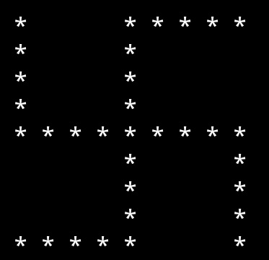

**Task 2:**

**Print the following pattern using nested loop in C++.**

